ReliefNet: AI Disaster Coordination System – LangGraph, FastAPI, React – Groq LLM

Project Description:
ReliefNet is a production-style, end-to-end AI-Powered Disaster Relief Coordination platform built with a FastAPI backend, a deterministic synthetic-data simulation engine, a LangGraph-inspired multi-agent orchestration layer, and a React + TypeScript + Vite “command-center” dashboard. It simulates a coastal Andhra Pradesh flood response in real time — population impact, shelter capacity, medical demand, food and water supply, transport, and network connectivity — and autonomously computes district-level priority scores, allocates limited relief resources, and re-plans delivery routes the moment conditions change.
The platform is organized around thirteen synthetic Andhra Pradesh districts loaded from a deterministic dataset (random seed 42), driven by a nine-stage agent command chain — Command Agent → Population → Shelter → Medical → Food → Transport → Weather → Network → Allocation Agent — with a Route Agent, a Conflict Resolution Agent, and a Monitoring Agent supporting it through structured Agent-to-Agent (A2A) messages. A NetworkX-based route graph of the relief corridor computes the fastest path between a warehouse and an affected district, and instantly recalculates a detour the moment a road edge is marked blocked.
A deterministic optimization policy (optimization/allocation.py) ranks every district by its computed priority score and assigns medicine, food, and water quantities to the highest-need districts first, resolving conflicts when several districts compete for the same limited stock. Every one of these decisions can be interrogated in natural language through the AI Copilot: a Groq-backed LLM (llama-3.3-70b-versatile) that answers strictly from the live synthetic scenario context, with a transparent, fully deterministic local-fallback responder that activates automatically whenever no GROQ_API_KEY is configured — so the platform runs end-to-end with zero external API keys required.

Scenarios
- Scenario 1: An operator clicks “Start Simulation” on the Command Center. The engine activates scenario SCN-FLOOD-001, “Severe Coastal Andhra Flood,” affecting Konaseema, Kakinada, East Godavari, Krishna, and West Godavari. The nine-agent command chain runs to completion, and the priority engine flags Konaseema as CRITICAL — priority 86, flood risk 96%, network status OFFLINE — while the Command Center's Health metrics update live: Critical Districts, Shelter Deficit, and Network Loss.
- Scenario 2: The operator clicks “Trigger Event” to simulate a road blockage on corridor R001, the primary route into Konaseema. The engine snapshots the current allocation as the old plan, removes the blocked edge from the NetworkX route graph, and recomputes the fastest surviving path — rerouting food through East Godavari and medicine through Warehouse W003 — automatically, with no operator approval needed, since ReliefNet's replanning is a low-risk, fully autonomous logistics decision. The dashboard's Route Optimizer view shows the before/after plan and the resulting +35-minute ETA shift.
- Scenario 3: An operator asks the AI Copilot, “Which district should receive medicine first?” The request is grounded in the live scenario context — priority scores, active allocations, recent events, and per-district flood risk — and sent to Groq; if no GROQ_API_KEY is configured, or the Groq request fails, the engine transparently falls back to its deterministic responder. Either way, the Copilot answers “Konaseema should receive medicine first” and returns structured evidence: the synthetic affected-population and shortage figures, the simulation's flood probability and network coverage, the optimizer's recommended quantity, and a supporting citation to the demo 3GPP knowledge base (3GPP TS 22.179, Mission Critical Push-to-Talk).

Technical Architecture:
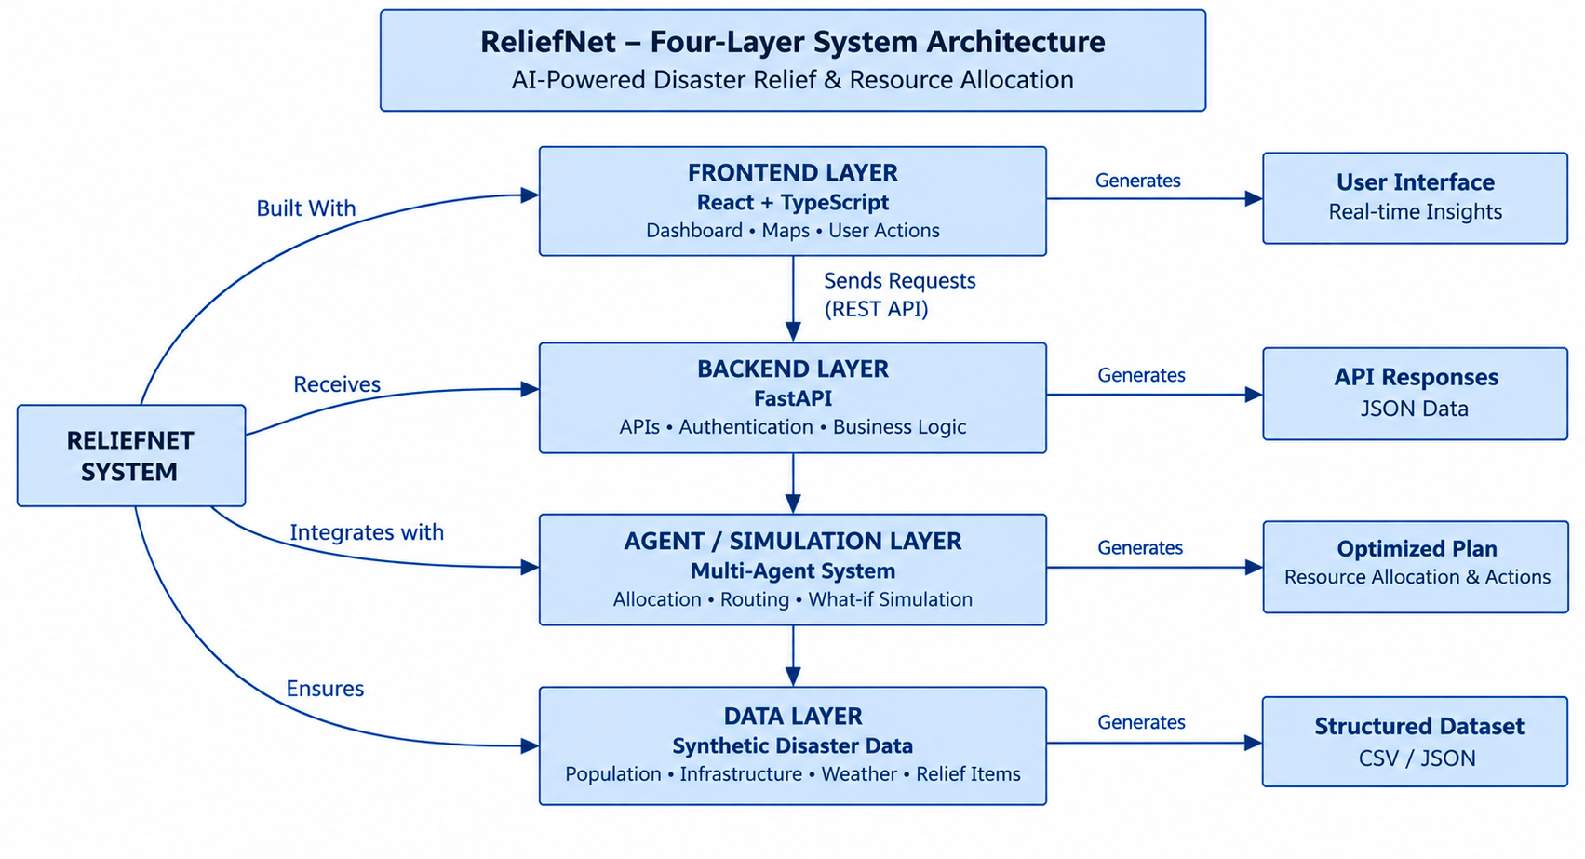

Description:
The application follows a four-layer architecture. The frontend is a React 18 + TypeScript single-page application built with Vite (no separate build step beyond the standard Vite pipeline), rendering a persistent sidebar of three collapsible groups — Command, Operations, and Network — plus a standalone AI Copilot panel, all communicating with the backend over REST/JSON. The FastAPI backend exposes this API under /api and /health, and registers permissive CORS middleware so the Vite dev server (which proxies /api requests to the backend) can reach it during local development.
Underneath the API sits the ReliefNetEngine, a deterministic, in-memory simulation core that loads every synthetic dataset from data/synthetic at start-up (seed 42) and tracks simulation_state — the active scenario, status, event log, allocations, old/new plan, and computed priority scores. Failures and events drive the LangGraph-inspired command chain (agents/graph.py), which hands district-level priority data to the deterministic optimizer (optimization/allocation.py) and the NetworkX route graph (routing/route_graph.py) for allocation and routing decisions. Every agent step is emitted as a structured A2A message (a2a/messages.py), and a fixed MCP tool registry (mcp/tools.py) exposes read-only access to district, weather, shelter, hospital, inventory, transport, network, and routing data to both the agent layer and the AI Copilot, which is grounded through a small demo 3GPP knowledge base (rag/knowledge.py) and an optional Groq LLM call (ai/groq_copilot.py).

Pre-requisites:
- Python Programming Proficiency: Python Documentation
- FastAPI & Pydantic Familiarity: FastAPI Documentation
- React, TypeScript & Vite Familiarity: React Documentation
- LangGraph / Multi-Agent Orchestration Concepts: LangGraph Documentation
- NetworkX Graph Algorithms: NetworkX Documentation
- Groq LLM API & Prompt Grounding: Groq API Documentation
- Version Control with Git: Git Documentation

Project Workflow:

Milestone 1: Model Selection and Architecture
- Activity 1.1: Configure environment secrets (.env) and the synthetic-data / AI Copilot settings.
- Activity 1.2: Research and select the multi-agent orchestration and deterministic-optimization design for disaster relief coordination.
- Activity 1.3: Define the architecture of the application, detailing interactions between the frontend, FastAPI backend, agent/orchestration layer, and the synthetic data layer.
- Activity 1.4: Set up the development environment, installing backend and frontend dependencies and preparing the synthetic dataset.

Milestone 2: Core Functionalities Development
- Activity 2.1: Develop the core functionalities: Simulation Engine, Multi-Agent Orchestration, Route Optimization, Resource Allocation, and the AI Copilot.
- Activity 2.2: Implement the FastAPI backend to manage routing, data loading, and the simulation/allocation/copilot endpoints.

Milestone 3: App.py Development
- Activity 3.1: Write the main application logic in main.py, establishing the FastAPI instance, environment loading, CORS middleware, and API routes.

Milestone 4: Frontend Development
- Activity 4.1: Design and develop the ReliefNet command-center dashboard using React, TypeScript, and Vite.
- Activity 4.2: Create dynamic data fetching and real-time rendering that connects every dashboard view to the live FastAPI backend.

Milestone 5: Deployment
- Activity 5.1: Prepare the application for local deployment by configuring the server environment and ensuring all dependencies are correctly installed.
- Activity 5.2: Public Deployment via Ngrok

Milestone 6: Conclusion

Milestone 1: Model Selection and Architecture
In this milestone, the focus is on selecting the right orchestration approach for autonomous disaster-relief coordination and defining the project's overall system architecture. This involves evaluating how a LangGraph-inspired agent chain, a deterministic optimizer, and a NetworkX route graph can work together to keep every automated allocation and routing decision fast, explainable, and reproducible, and ensuring the chosen design aligns with the project's goal of coordinating relief for a simulated disaster without depending on any live external data or API key.

Activity 1.1: Configure Environment Secrets and API Credentials
Before the AI Copilot can reach the Groq API (or run entirely offline on its local fallback), the project needs a set of environment variables. Follow the steps below to set them up.
- Step 1 — Copy the Environment Template: Duplicate .env.example into a new .env file at the project root.
cp .env.example .env
- Step 2 — Configure the App and Data Settings: APP_NAME, APP_ENV, BACKEND_PORT, and FRONTEND_PORT identify the service and its ports, while RANDOM_SEED and SYNTHETIC_MODE keep the disaster dataset deterministic and clearly flagged as synthetic.
- Step 3 — Configure the AI Copilot Provider: GROQ_API_KEY and GROQ_MODEL point the Copilot at Groq's llama-3.3-70b-versatile model; leaving GROQ_API_KEY blank is fully supported — the Copilot automatically serves answers from its deterministic local-fallback responder instead.
APP_NAME=RELIEFNET
APP_ENV=development
DATABASE_URL=sqlite:///./reliefnet.db
BACKEND_PORT=8000
FRONTEND_PORT=5173
RANDOM_SEED=42
SYNTHETIC_MODE=true
3GPP_DEMO_KB_PATH=./data/3gpp_demo
GROQ_API_KEY=your_groq_api_key_here
GROQ_MODEL=llama-3.3-70b-versatile
- Step 4 — Verify the Settings Load Automatically: main.py calls load_dotenv() against the project-root .env before the FastAPI app is created, so every module that reads os.getenv() picks up the same configuration.
env_path = Path(__file__).resolve().parents[2] / ".env"
load_dotenv(dotenv_path=env_path, override=True)
- Important — Never Commit Secrets: Keep .env listed in .gitignore and rotate any key that was ever committed to a shared .env.example.

Activity 1.2: Research and Select the Orchestration Approach
- Understand the Project Requirements: Review the system's needs — assessing district-level disaster impact, prioritizing scarce relief resources, and re-routing deliveries the moment a road or supply condition changes.
- Explore a LangGraph-Style Command Chain: Examine how a nine-stage agent sequence — Command → Population → Shelter → Medical → Food → Transport → Weather → Network → Allocation — gives full visibility into every factor behind a priority score, supported by a Route Agent, a Conflict Resolution Agent, and a Monitoring Agent.
- Evaluate a Controlled MCP Tool Registry: Assess a fixed set of read-only tool functions (district, weather, rainfall, population, shelter, hospital, food, medical, transport, network, and road-status getters, plus route, allocation, and replanning tools) as the only interface the agent layer and the AI Copilot are ever given into the simulation.
- Select the Orchestration Design: Adopt a deterministic allocation policy (optimize_allocation, resolve_conflicts) and a NetworkX shortest-path router (calculate_route, route_after_blockage) as the two decision engines the agent chain always defers to, so every relief decision stays reproducible under the fixed random seed.

Activity 1.3: Define the Architecture of the Application
- Draft an Architectural Diagram: Create a visual representation of the four layers — the React/TypeScript frontend, FastAPI backend, agent/orchestration layer, and the synthetic data layer — as shown above.
- Detail Frontend Functionality: Outline how operators interact with the app: reviewing the Command Center, browsing the Situation Map and Incidents log, inspecting Operations views (Population, Shelters, Medical, Food, Transport, Relief Teams), monitoring the Network group, and querying the AI Copilot.
- Outline Backend Responsibilities: Specify how the FastAPI backend exposes /health, /api/districts, /api/weather, /api/population, /api/simulation/start, /api/simulation/reset, /api/simulation/events, /api/allocation/run, /api/replanning/run, /api/agents/status, /api/audit, and /api/copilot/query.
- Describe AI Integration Points: Define how simulation_state flows through the ReliefNetEngine, how the deterministic optimizer and route graph produce allocation and routing decisions, and how the AI Copilot grounds every answer in copilot_context() rather than inventing facts.

Activity 1.4: Set Up the Development Environment
- Install Python and Node.js: Ensure Python 3.11+ and Node.js 18+ are installed on the machine.
- Create a Virtual Environment: Isolate backend dependencies using venv.
python -m venv .venv
# Windows: .venv\Scripts\activate
# macOS/Linux: source .venv/bin/activate
pip install -r requirements.txt
- Backend Dependencies: requirements.txt pins fastapi, uvicorn[standard], sqlalchemy, pydantic, pydantic-settings, networkx, pandas, numpy, scipy, ortools, plotly, python-dotenv, httpx, and pytest for the API, routing/optimization, and test suite.
- Set Up the Frontend: Install the React/TypeScript/Vite toolchain declared in frontend/package.json (react, react-dom, lucide-react; vite, typescript, tailwindcss as dev dependencies).
cd frontend
npm install
cd ..
- Application Structure: The project is organized as backend/app/{agents, a2a, ai, mcp, optimization, rag, routing, simulation} and frontend/src, keeping the agent logic, controlled tool registry, and UI cleanly separated, with data/synthetic holding every CSV/JSON dataset and docs/ holding the project's architecture, agent-design, API, data-model, simulation, and testing notes.
- Deterministic Data Initialization: ReliefNetEngine.__init__() loads districts.csv, population.csv, and weather.csv with pandas and parses scenarios.json (random_seed: 42) at start-up, so the dashboard is populated with the same thirteen-district Andhra Pradesh dataset on every run — no database migration step is required.

Milestone 2: Core Functionalities Development
Milestone 2 builds out the core functional modules of the system and the FastAPI backend that powers them, turning the architecture defined in Milestone 1 into a working, data-driven relief-coordination platform.

Activity 2.1: Develop the Core Functionalities
- Simulation Engine: The ReliefNetEngine class (simulation/engine.py) loads every synthetic dataset, tracks simulation_state (scenario, status, event_log, allocations, old_plan, new_plan, priority_scores), and exposes start_simulation(), reset_simulation(), trigger_event(), run_allocation(), and run_replanning().
- Multi-Agent Orchestration: run_agent_chain() (agents/graph.py) drives the nine-stage command chain end-to-end and reports a completed status, the full agent list, and a computed priority_score, while build_agent_message() (a2a/messages.py) packages each agent's result into a structured A2A status message.
- Controlled MCP Tool Registry: mcp/tools.py exposes a fixed set of read-only functions — get_district_data, get_weather, get_rainfall, get_population, get_shelters, get_hospitals, get_food_inventory, get_medical_inventory, get_transport, get_network_status, get_road_status, calculate_route_tool, run_allocation_tool, run_replanning_tool, and get_simulation_state — as the only interface into simulation data.
- Resource Allocation Optimization: optimize_allocation() (optimization/allocation.py) ranks districts by priority score and assigns medicine, food, and water quantities to the warehouses that serve them; resolve_conflicts() greedily distributes a limited resource pool across competing district demands, highest priority first.
- NetworkX Route Optimization: build_route_graph() (routing/route_graph.py) constructs a directed graph of the relief corridor with per-edge distance, travel time, and risk; calculate_route() returns the shortest path by travel time, and route_after_blockage() removes a blocked edge and recalculates the detour.
- 3GPP Knowledge Base (RAG): get_demo_3gpp_documents() and search_3gpp() (rag/knowledge.py) provide a small, clearly-labeled demo knowledge base of three 3GPP public-safety standards documents, cited as supporting evidence in Copilot answers about network resilience and emergency communications.
- AI Copilot: generate_copilot_answer() (ai/groq_copilot.py) sends a grounded prompt to the Groq chat-completions API under a system prompt that forbids inventing quantities, routes, or standards; engine.answer_copilot_with_ai() calls it first and transparently falls back to the deterministic answer_copilot() responder whenever Groq is unavailable or unconfigured.

Activity 2.2: Implement the FastAPI Backend
- Define the API Surface: main.py declares one FastAPI() app exposing /health, /api/districts, /api/weather, /api/population, /api/simulation/start, /api/simulation/reset, /api/simulation/events, /api/allocation/run, /api/replanning/run, /api/agents/status, /api/audit, /api/test-env, and the async /api/copilot/query.
- Load Environment Before App Creation: load_dotenv() runs against the project-root .env at import time, so GROQ_API_KEY and GROQ_MODEL are available to every request handler without extra plumbing.
- Enforce CORS: main.py registers CORSMiddleware with allow_origins=["*"] so the Vite-served frontend (proxying /api to the backend) can call every route during local development.
app = FastAPI(title="RELIEFNET", version="1.0.0")
app.add_middleware(
CORSMiddleware,
allow_origins=["*"], allow_credentials=True,
allow_methods=["*"], allow_headers=["*"],
)
- Diagnostics Endpoints: /health reports whether GROQ_API_KEY is configured, and /api/test-env exposes non-secret diagnostic details (key presence and length, configured model, and matching env var names) to help verify a deployment without ever returning the key itself.

Milestone 3: App.py Development
Milestone 3 focuses on the application entry point that serves as the backbone of the backend — backend/app/main.py. In this milestone, environment variables are loaded, the FastAPI instance is created, CORS is registered, and every simulation, allocation, and Copilot route is wired to the ReliefNetEngine singleton.

Activity 3.1: Writing the Main Application Logic in main.py
- Load Environment Variables First: main.py resolves the project-root .env path and calls load_dotenv(dotenv_path=env_path, override=True) before the FastAPI() app object is constructed.
from pathlib import Path
from dotenv import load_dotenv
env_path = Path(__file__).resolve().parents[2] / ".env"
load_dotenv(dotenv_path=env_path, override=True)
app = FastAPI(title="RELIEFNET", version="1.0.0")
- Instantiate the Engine Singleton: simulation/engine.py builds a module-level engine = ReliefNetEngine() at import time, so every route handler in main.py shares one already-loaded, deterministic simulation instance.
- Expose the Simulation Lifecycle: POST /api/simulation/start activates SCN-FLOOD-001 and computes priority scores; POST /api/simulation/reset clears simulation_state back to idle; POST /api/simulation/events applies a triggered event and immediately produces a replanned allocation.
@app.post("/api/simulation/start")
def start_simulation() -> dict:
return engine.start_simulation()
@app.post("/api/simulation/events")
def trigger_event(payload: dict) -> dict:
return engine.trigger_event(payload)
- Expose Allocation and Routing: POST /api/allocation/run returns the deterministic resource-allocation plan, and POST /api/replanning/run re-invokes the routing logic against the current blockage state and returns the updated plan.
- Ground the AI Copilot Endpoint: The async /api/copilot/query route awaits engine.answer_copilot_with_ai(question), which tries Groq first and transparently annotates the response with its source — "groq" or "local_fallback" — so the frontend can always show where an answer came from.
@app.post("/api/copilot/query")
async def copilot_query(payload: dict) -> dict:
return await engine.answer_copilot_with_ai(payload.get("question", ""))
- Automatic API Documentation: Because every route is a plain FastAPI endpoint, FastAPI generates a live, interactive Swagger UI at /docs and a ReDoc view at /redoc with zero extra configuration.

Milestone 4: Frontend Development
Milestone 4 focuses on building the ReliefNet command-center dashboard — a React 18 + TypeScript single-page application built with Vite — and wiring every one of its operational views to live data from the FastAPI backend.

Activity 4.1: Designing and Developing the User Interface
- Set Up the Base Application Shell: main.tsx bootstraps React into the DOM, and App.tsx renders a LandingPage.tsx introduction screen (“Launch Dashboard” / “Explore Platform”) that transitions into the operational dashboard shell once the operator enters it.
- Build the Sidebar Navigation: Three collapsible sidebarGroups drive navigation — Command (Command Center, Situation Map, Incidents), Operations (Population, Shelters, Medical, Food, Transport, Relief Teams), and Network (Network Status, Connectivity, Infrastructure) — plus a standalone AI Copilot button pinned beneath the groups.
- Establish the Visual Language: styles.css and landing.css define the dashboard's dark command-center palette, SYNTHETIC/SIMULATION status badges, metric cards, and status banners; a shared badge-row keeps every view clearly labeled as running on synthetic data.
- Build the Situation Map and Live Widgets: SituationMapVisual renders an interactive district map with priority-based coloring and hover/selection state, while ResponseTrendChart and CycloneTracker render supporting analytics widgets on the Command Center.
- Compose Section-Level Insight Cards: A sectionInsights lookup renders three contextual KPI cards for every operational view — for example, “Flood Risk 96%” and “Road Block R001” on the Situation Map, or “ICU 15 Available” and “Medical stock 6.4K” on the Medical view — so each page opens with an at-a-glance summary before its detail tables.

Activity 4.2: Creating Dynamic Content Rendering
- Centralize API Calls: A fetchJson<T>() helper wraps every backend call so every page component fetches districts, weather, population, allocations, agent status, and audit data through one typed function.
async function fetchJson<T>(url: string, options?: RequestInit): Promise<T> {
const res = await fetch(url, options)
if (!res.ok) throw new Error(`Request failed: ${res.status}`)
return res.json() as Promise<T>
}
- Run Scenarios from the UI: The START SIMULATION and TRIGGER EVENT buttons in the topbar call /api/simulation/start and /api/simulation/events, then refresh the district table, allocation table, and the Scenario / Status / Mode status banner.
- Render Live District and Allocation Data: The Situation Map, district table, and allocation, vehicle, shelter, hospital, and food tables render live data returned by the backend, with a small set of fallback* constants used only until the first live fetch resolves.
- Wire the AI Copilot Panel: The AI Copilot view posts free-text operator questions to /api/copilot/query and renders the returned answer together with its status (Groq or local-fallback) and evidence/context payload, so the operator always sees where an answer came from.
- Format Numbers Consistently: Shared formatCount and formatCompact helpers use Intl.NumberFormat('en-IN') so population, stock, and allocation figures render in Indian numbering conventions across every dashboard view.

Milestone 5: Deployment
In Milestone 5, the focus is on deploying the application first locally to verify correct operation, and then publicly via Ngrok to share the dashboard over a secure, accessible URL. This involves configuring the server environment, managing backend and frontend dependencies, and launching both processes for real-world use.

Activity 5.1: Preparing the Application for Local Deployment
- Set Up a Virtual Environment and Install Backend Dependencies:
python -m venv .venv
.venv\Scripts\activate # Windows
source .venv/bin/activate # macOS/Linux
pip install -r requirements.txt
- Configure Environment Variables: Create a .env file in the project root from .env.example and add a Groq API key if live Copilot answers are wanted; the app loads this automatically using python-dotenv at start-up.
cp .env.example .env
# then edit .env and set GROQ_API_KEY=your_groq_api_key_here
- Start the Backend Server:
uvicorn backend.app.main:app --reload --host 0.0.0.0 --port 8000
- Start the Frontend (New Terminal): The Vite dev server proxies every /api request to the backend on port 8000, as configured in vite.config.js.
cd frontend
npm install
npm run dev -- --host 0.0.0.0 --port 5173
- Access the Application: Frontend at http://localhost:5173, backend API at http://localhost:8000, and interactive API docs at http://localhost:8000/docs.

Activity 5.2: Public Deployment via Ngrok
Ngrok creates a secure tunnel from a public URL to your local FastAPIserver, making the app accessible from anywhere without a cloud hosting provider.
Install Ngrok and pyngrok:
- Install the pyngrok Python wrapper, which manages Ngrok programmatically within your Python project:
pip install pyngrok
- Download and install the Ngrok client from https://ngrok.com/download.
- Click on “Microsoft Store Installer”.
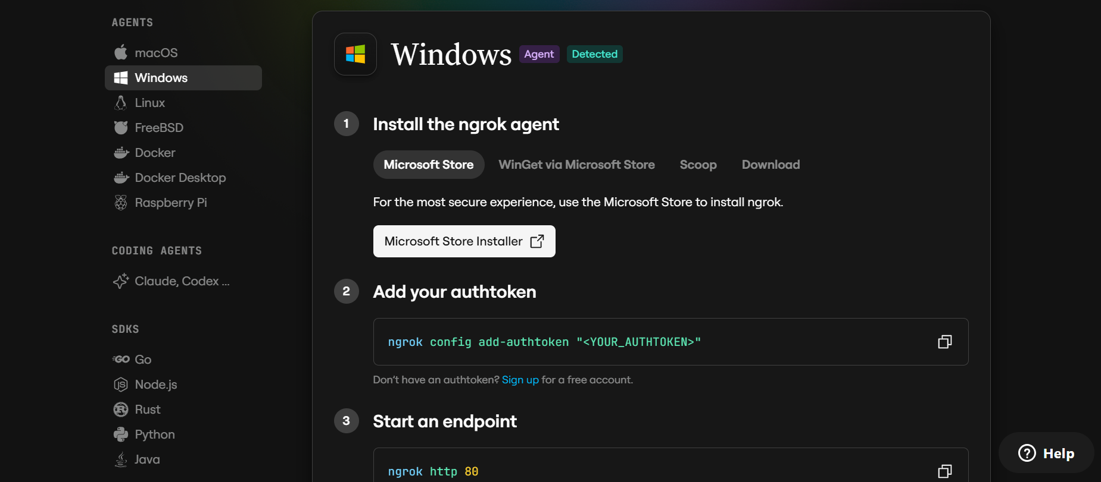
Configure Your Ngrok Authtoken:
- Sign up at ngrok.com and copy your authtoken from the Ngrok dashboard.
- The run_public.py script sets the authtoken automatically using:
D:\projects>ngrok.set_auth_token("YOUR_NGROK_AUTHTOKEN")
- Replace the TOKEN value in run_public.py with your own Ngrok authtoken before running.

Run the Public Deployment Script:
- Instead of running app.py directly, launch run_public.py to start both the Ngrok tunnel and the Flask server:
D:\projects>python run_public.py
- The script opens an HTTP tunnel on port 5000 and prints the live public URL in the terminal:
======================================================
YOUR PUBLIC WEBSITE URL IS LIVE!
URL: https://xxxx-xx-xx-xxx-xx.ngrok-free.app
======================================================
- Share this URL with anyone who can access your CaptionAI app directly from their browser without any installation.

Important Notes:
- debug=False is required in run_public.py to prevent Flask from spawning a reloader process, which would interfere with Ngrok’s tunnel management.
- The public URL changes each time you restart run_public.py (on the free Ngrok plan). For a persistent URL, upgrade to a paid Ngrok plan and configure a reserved domain.
- Ngrok free tier sessions expire after a few hours of inactivity. Restart run_public.py to get a new URL when this happens.

Exploring the Dashboard:

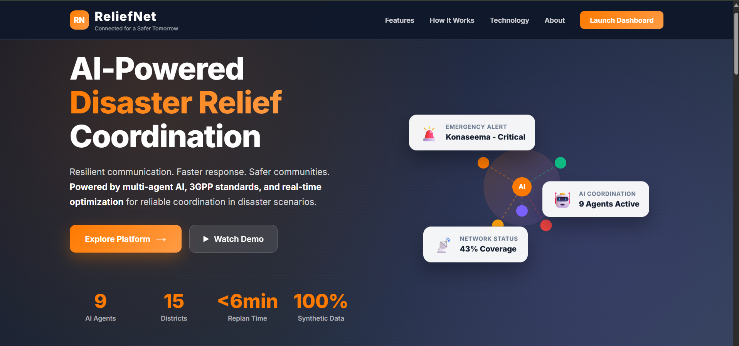

Command Center:

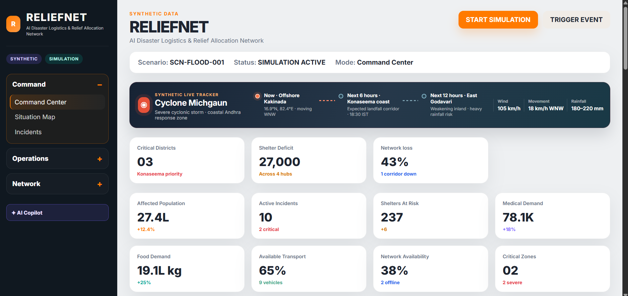

Description: The default landing view and the dashboard's mission-control home. It opens with the SYNTHETIC / SIMULATION status badges, the START SIMULATION and TRIGGER EVENT actions, live metric cards (Affected Population, Active Incidents, Shelters At Risk, Medical Demand, Food Demand, Available Transport, Network Availability, Critical Zones), and Command-group insight cards summarizing Critical Districts, Shelter Deficit, and Network Loss.

Situation Map:
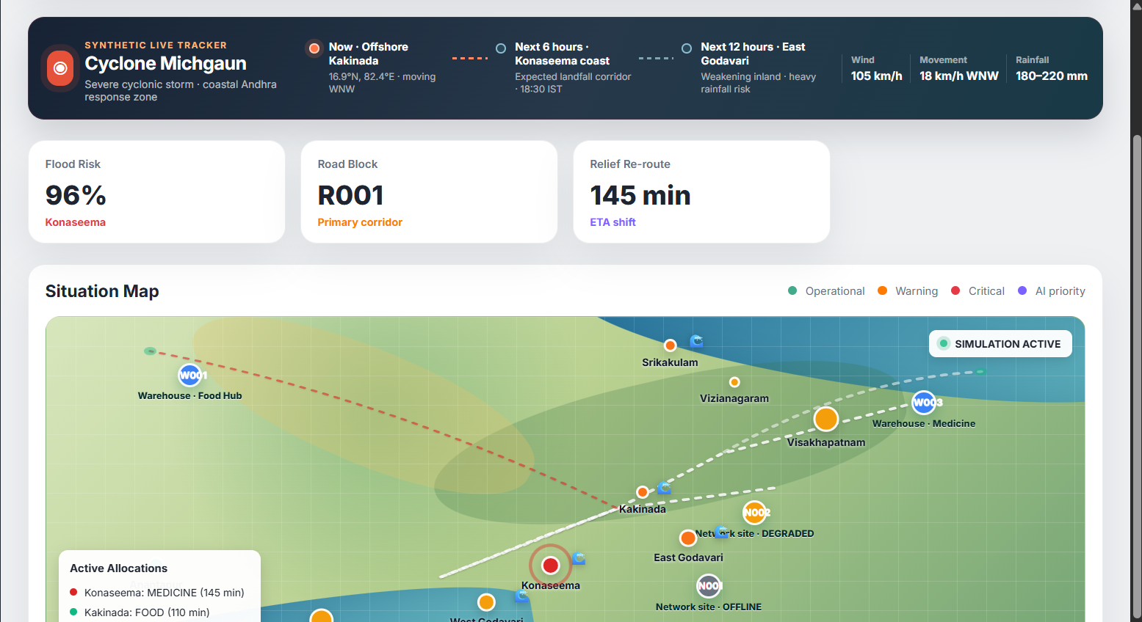

Description: An interactive district-level map (SituationMapVisual) showing every affected district colored by priority, with hover and selection detail. Insight cards summarize Flood Risk, Road Block, and Relief Re-route ETA, and a district table lists each district's priority score, category, flood risk, and network status.

Incidents:
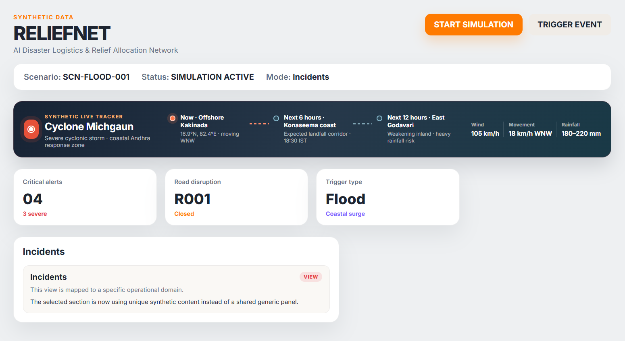

Description: A log of active incidents — critical alerts, road disruptions, and the disaster's trigger type — giving the operator a chronological view of what the simulation has detected since the scenario started.

Population, Shelters & Medical:
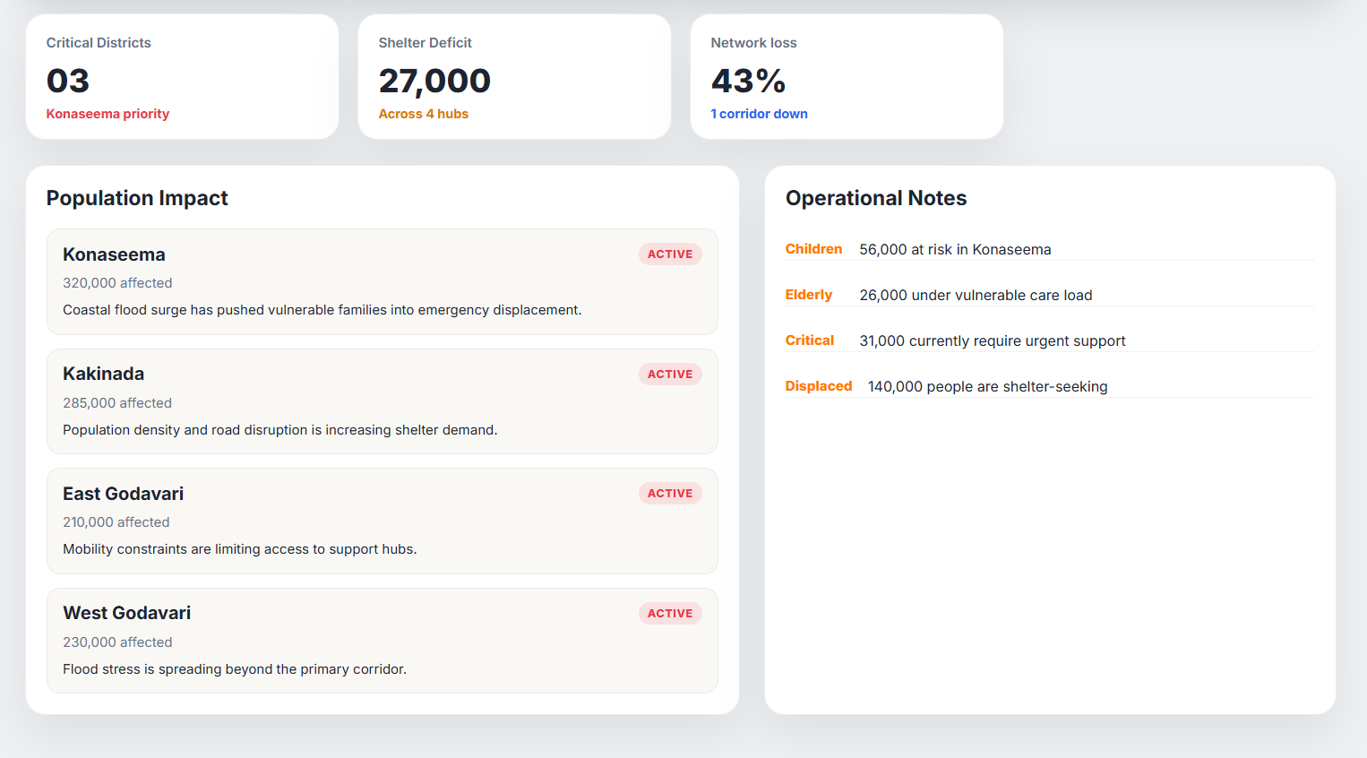
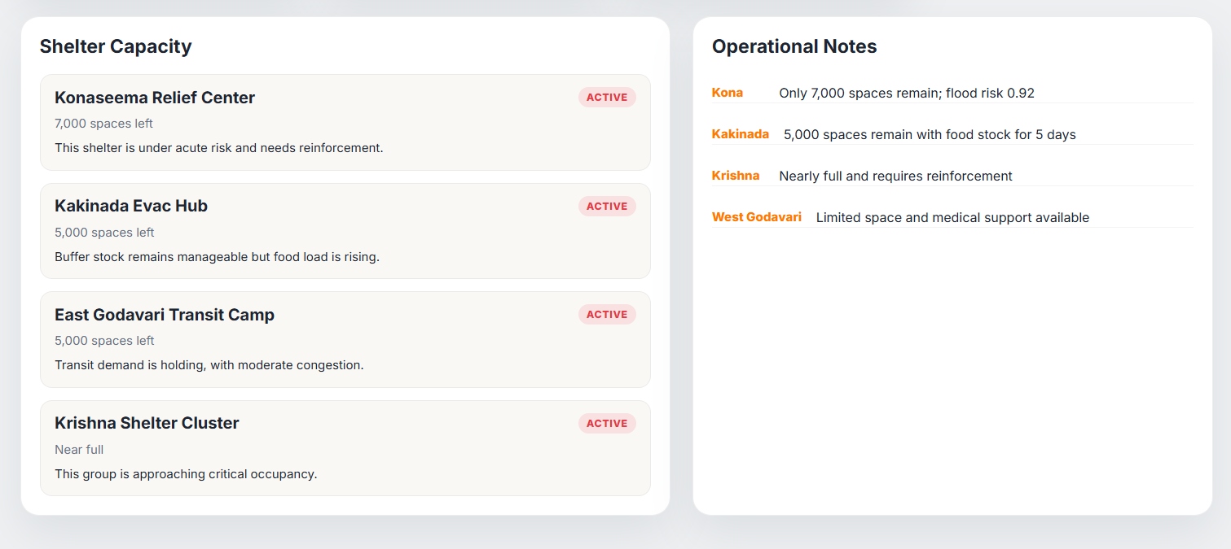

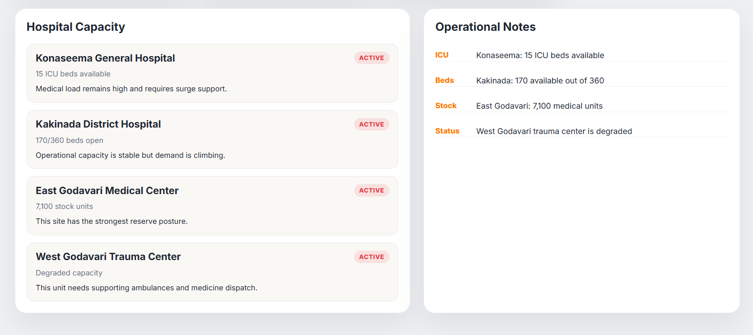
Description: The Operations group's needs-assessment views. Population summarizes affected, displaced, and vulnerable counts per district; Shelters lists at-risk and available shelter capacity against the shelterRows dataset; Medical lists ICU and bed availability, and medical stock levels, against the hospitalRows dataset.

Food & Transport:
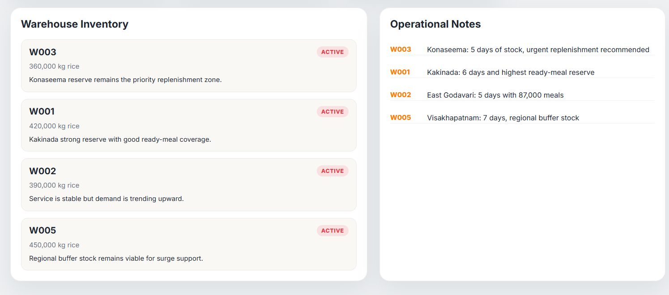
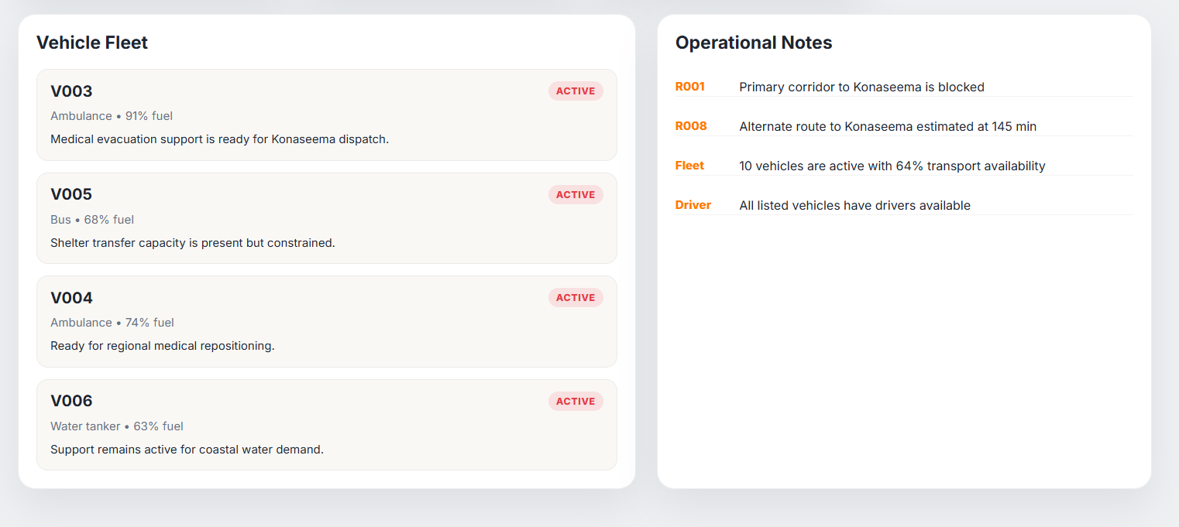

Description: Food shows rice, water, and ready-meal stock by warehouse (foodRows); Transport shows available vehicles, open roads, and the ETA shift caused by the most recent road blockage, backed by the vehicleRows fleet dataset (ambulances, buses, water tankers).

Relief Teams:
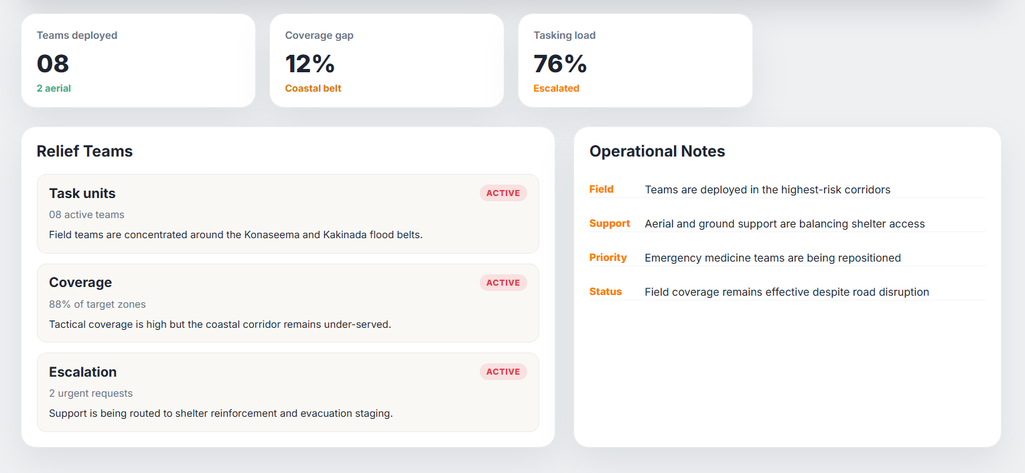

Description: Deployment status for field relief teams — teams deployed, coverage gaps in the coastal belt, and current tasking load — giving the operator a view of on-the-ground response capacity alongside the resource-allocation plan.

Network Status, Connectivity & Infrastructure:
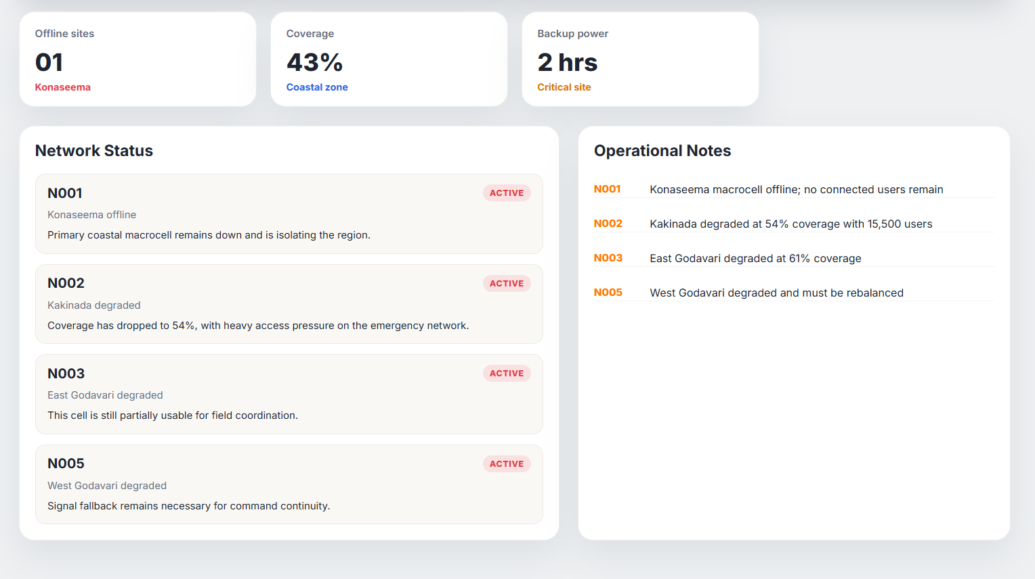

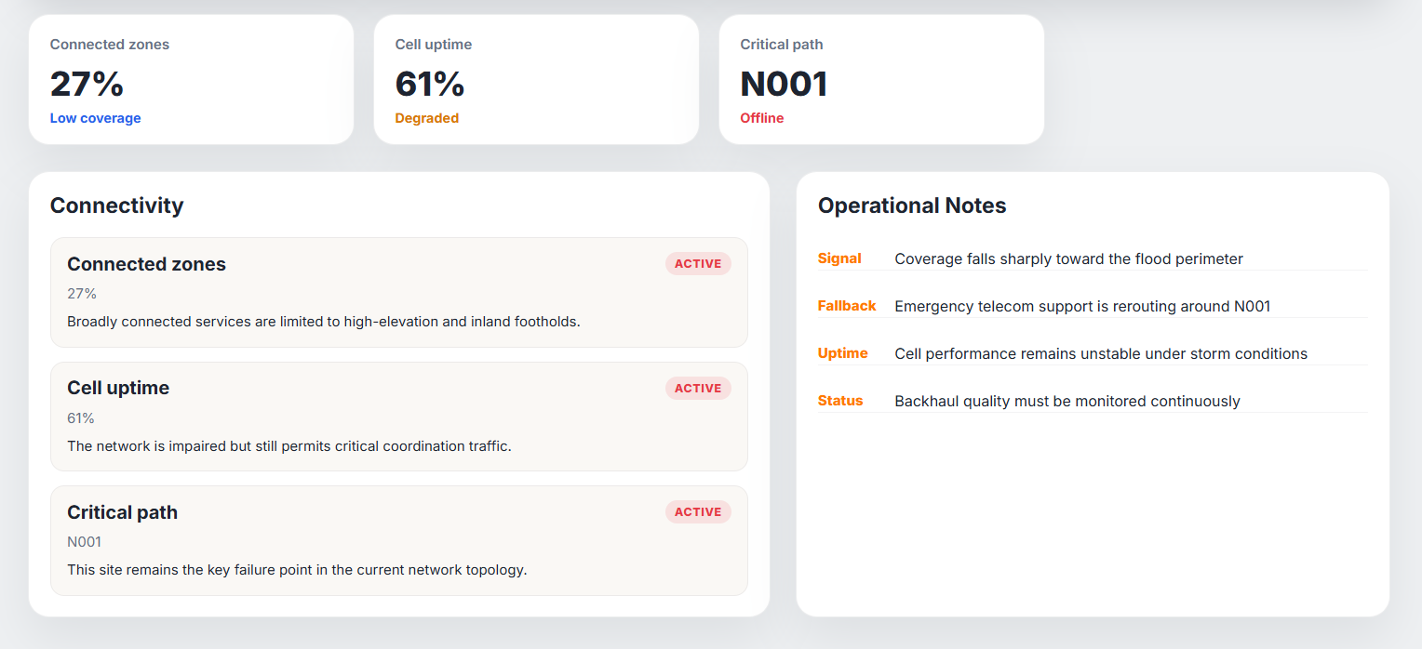

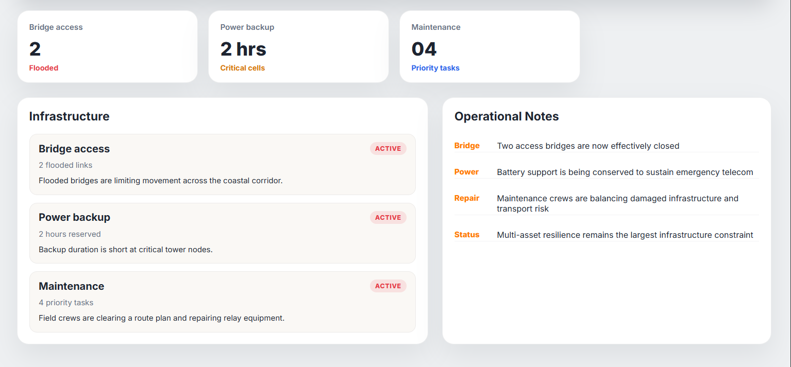

Description: The Network group tracks telecom resilience during the disaster: Network Status lists offline sites and remaining backup power (networkRows); Connectivity tracks connected-zone percentage and cell uptime; Infrastructure tracks flooded bridge access and pending maintenance tasks on critical cell sites.

AI Copilot:
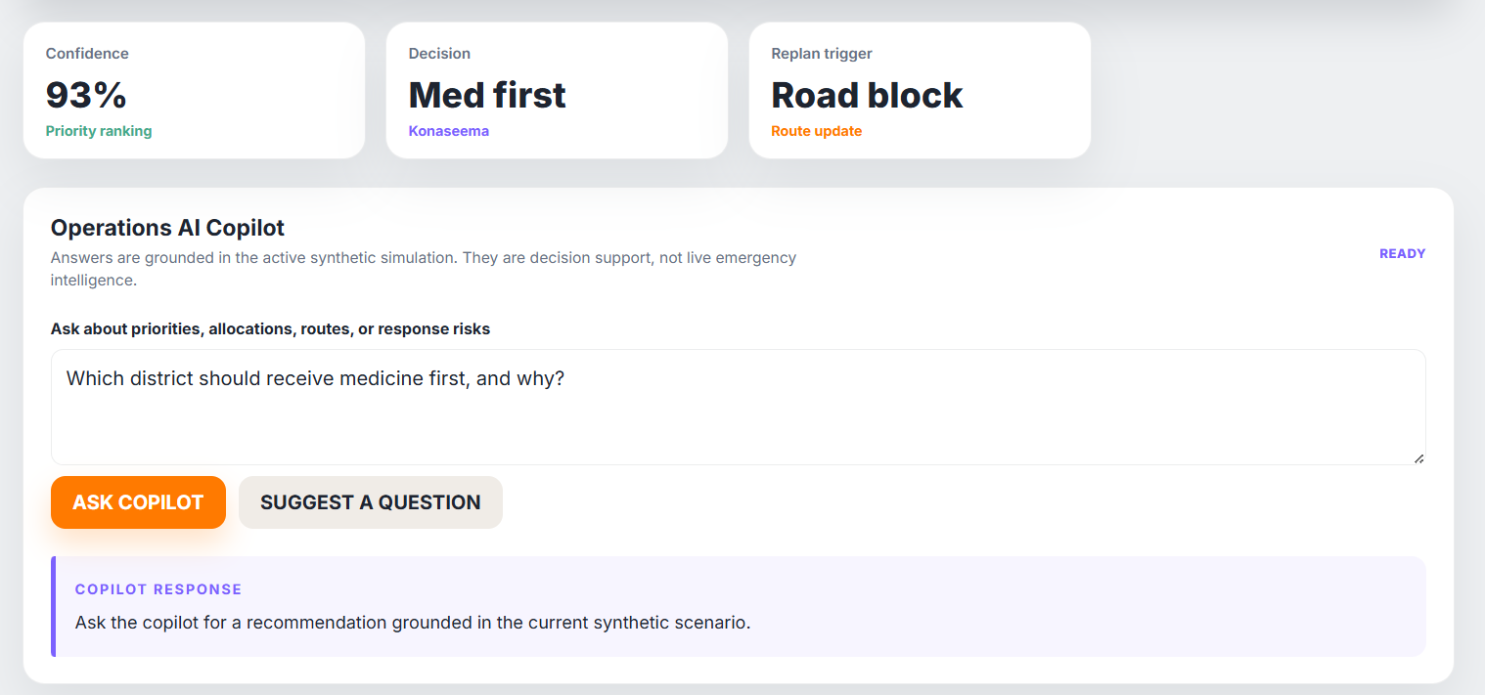

Description: The natural-language query panel, pinned beneath the sidebar. Operators can ask questions like “Which districts need medical supplies most urgently?” and receive a grounded answer — sourced from Groq or the local-fallback responder — together with its full evidence payload (synthetic data, simulation result, AI inference, optimization result, and 3GPP citation), and insight cards summarizing Confidence, Decision, and Replan Trigger.

Conclusion:
ReliefNet is an AI-powered disaster relief coordination platform built with FastAPI, a deterministic synthetic simulation engine, and a LangGraph-inspired multi-agent orchestration layer connected to a controlled MCP tool registry. It turns a simulated coastal Andhra Pradesh flood into a continuously re-planned, fully explainable relief operation — computing district priority scores, allocating medicine, food, and water to the highest-need districts, and rerouting deliveries the instant a road is blocked — while keeping every decision answerable in plain language through the AI Copilot and grounded in a clearly labeled, deterministic synthetic dataset.
The project, which spanned multi-agent orchestration and architecture design, a deterministic optimization and NetworkX routing core, a demo 3GPP knowledge base, and a real-time React command-center frontend, demonstrates how a reproducible, well-traced agent pipeline combined with a transparent, gracefully-degrading AI Copilot can support humanitarian decision-making without ever depending on a live external API. Looking ahead, the platform is positioned to grow from its current in-memory, synthetic-data simulation into a system wired to genuine weather, population, and logistics data sources under proper ethical review, to layer in a persistent database in place of in-memory state, and to extend the controlled tool registry and agent chain to additional disaster types beyond coastal flooding — evolving it from a demonstration platform into a validated, production-grade relief-coordination system.

